**4.1 Socio-demographic characteristics**

**Table 4.1 Socio-demographic characteristics**

| **Characteristic** | **N = 123** |
| --- | --- |
| **Mean Age (range)** | 22.0 (19.0, 28.0) |
| **Age group** |  |
| 10-19years | 33 (27%) |
| 20-29years | 62 (50.4%) |
| 30-39years | 22 (17.9%) |
| 50-59years | 3 (2.4%) |
| 60-69years | 3 (2.4%) |
| **Gender** |  |
| Female | 89 (72%) |
| Male | 34 (28%) |
| **Ethnicity** |  |
| Ibo | 14 (11%) |
| Others | 5 (4.1%) |
| Yoruba | 104 (85%) |
| **Marital status** |  |
| Married | 12 (9.8%) |
| Separated | 5 (4.1%) |
| Single | 106 (86%) |
| **Religion** |  |
| Christianity | 69 (56%) |
| Islam | 54 (44%) |
| **Education level** |  |
| Primary | 7 (6.5%) |
| Secondary | 82 (76%) |
| Tertiary | 19 (18%) |
| Unknown | 15 |
| **Education level of father** |  |
| Primary | 14 (11%) |
| Secondary | 67 (54%) |
| Tertiary | 42 (34%) |
| **Education level of mother** |  |
| Primary | 20 (16%) |
| Secondary | 66 (54%) |
| Tertiary | 37 (30%) |
| **Family type** |  |
| Monogamous | 80 (65%) |
| Polygamous | 43 (35%) |
| **Family size** |  |
| Small | 45 (37%) |
| Large | 78 (63%) |
| **Number of sibling with sickle cell disease** |  |
| 1 | 33 (27%) |
| 2 | 90 (73%) |
| **Average Income** |  |
| None | 56 (46%) |
| 1k-10k | 7 (5.7%) |
| 10k-100k | 55 (45%) |
| >100k | 5 (4.1%) |
| **Source of healthcare financing** |  |
| HMO | 10 (8.1%) |
| Self | 113 (92%) |

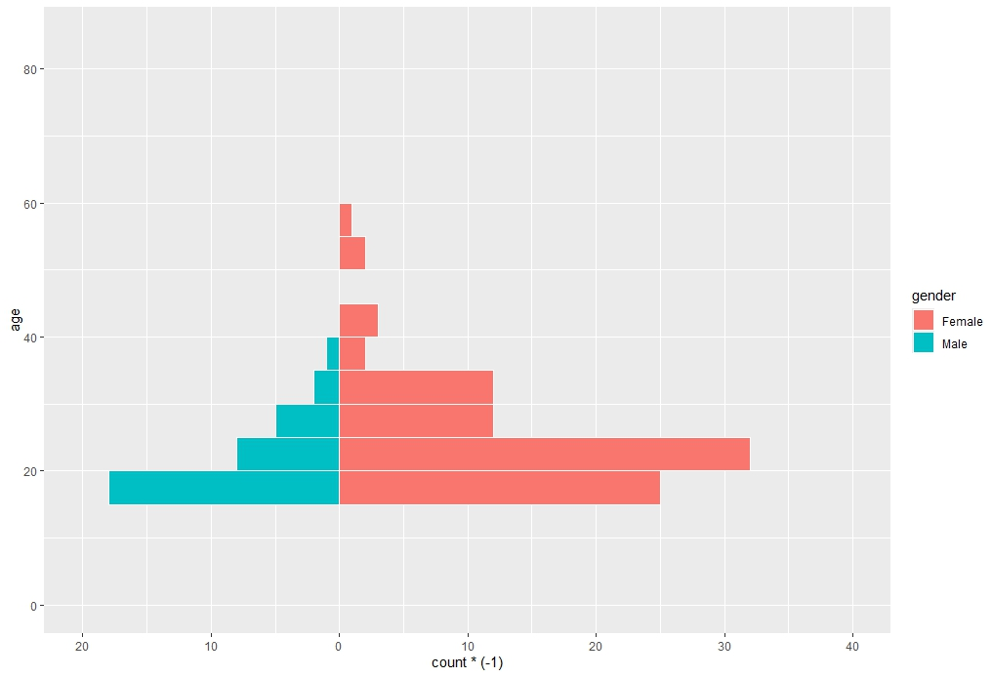

Figure 4.1 Age-sex pyramid of the participants in this study

4.1.2 Clinical history

Table 4.1.2 Clinical history

| **Characteristic** | **N = 123** |
| --- | --- |
| **Type of Sickle cell disease** |  |
| HbSC | 17 (14%) |
| HbSS | 106 (86%) |
| Knowledge of steady PCV (Yes) | 39 (34%) |
| Mean PCV (range) | 26.0 (22.5, 28.0) |
| Last time PCV was checked |  |
| <1 year ago | 3 (5.1%) |
| >5 years ago | 3 (5.1%) |
| 1-2 years ago | 51 (86%) |
| 2-5 years ago | 2 (3.4%) |
| Unknown | 64 |
| Mean value of last PCV (range) | 24.0 (20.0, 28.0) |
| Unknown | 69 |
| Number of crisis in past 6 months |  |
| 1 | 83 (67%) |
| 2 | 40 (33%) |
| Do you know the type of crises (Yes) | 56 (46%) |
| Specify the crises |  |
| Bloodly urine | 2 (3.6%) |
| Body aches and malaria | 1 (1.8%) |
| Body and chest | 2 (3.6%) |
| Body pain | 16 (29%) |
| Chest pain | 1 (1.8%) |
| Haemolytic | 2 (3.6%) |
| Sickle cell crises of bone pain | 19 (34.1%) |
| Vasooccloive | 13 (23%) |
| Unknown | 67 |
| Number of hospital admission |  |
| 0 | 79 (64%) |
| 1 | 44 (36%) |
| Number of blood transfusion |  |
| 0 | 101 (82%) |
| 1 | 22 (18%) |
| No of visits for chronic pain |  |
| 0 | 66 (54%) |
| 1 | 57 (46%) |
| Presence of complication (Yes) | 51 (100%) |

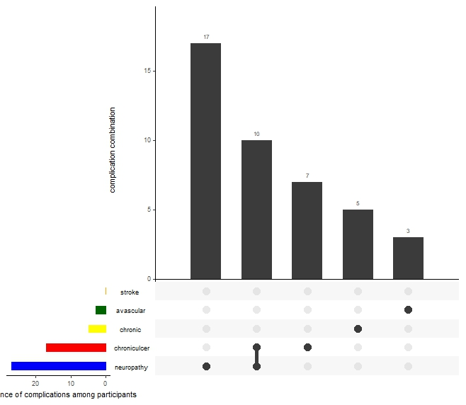Figure 4.1 Presence of complications among participants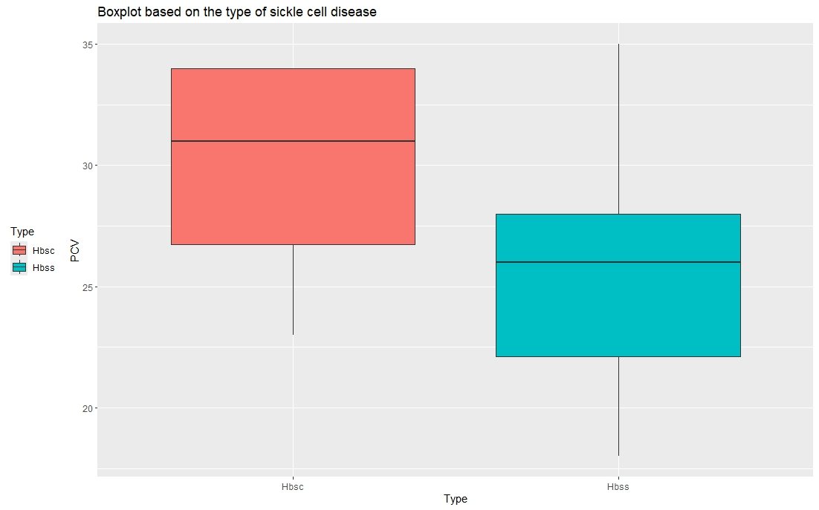

Figure 4.1b Boxplot showing PCV level among HbSC and HBSS

4.2 Prevalence of Depression Among Participants

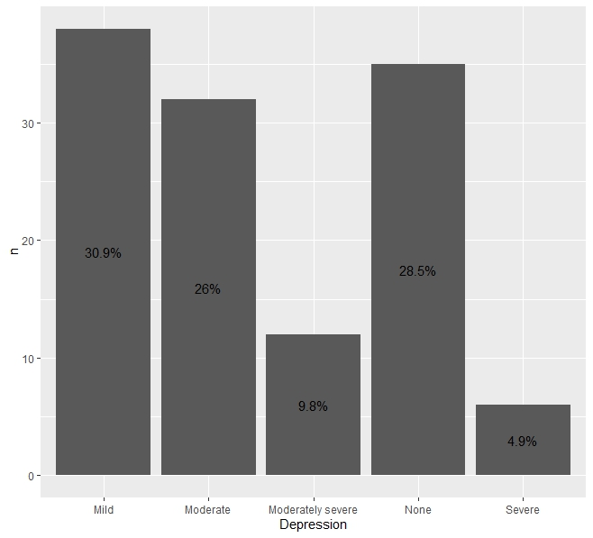

Figure 4.2a Prevalence of Depression in this study

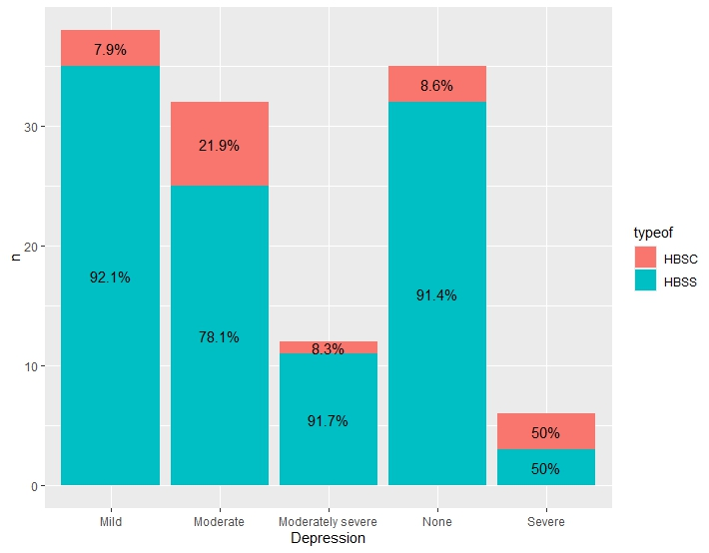

Figure 4.2b Prevalence of Depression among HBSC and HBSS in this study

4.3 Health-related Quality of Life of the participants

4.3 Descriptive statistics of the domains and components of the Short form-36

| variable | n | min | max | median | IQR | mean | s.d | s.e |
| --- | --- | --- | --- | --- | --- | --- | --- | --- |
| PF | 123 | 0.000 | 100.00 | 75.000 | 35.000 | 69.153 | 24.458 | 2.205 |
| RP | 123 | 0.000 | 100.00 | 25.000 | 100.000 | 46.545 | 41.529 | 3.745 |
| REP | 123 | 0.000 | 100.00 | 66.667 | 100.000 | 52.575 | 45.570 | 4.109 |
| EF | 123 | 10.000 | 100.00 | 50.000 | 15.000 | 47.276 | 14.160 | 1.277 |
| EWB | 123 | 0.000 | 100.00 | 48.000 | 24.000 | 45.789 | 16.597 | 1.497 |
| SF | 123 | 0.000 | 100.00 | 50.000 | 12.500 | 44.512 | 20.254 | 1.826 |
| PAIN | 123 | 10.000 | 100.00 | 32.500 | 54.750 | 36.419 | 28.887 | 2.605 |
| GH | 123 | 10.000 | 75.00 | 45.000 | 15.000 | 42.967 | 14.241 | 1.284 |
| PCS | 123 | 18.250 | 86.25 | 50.625 | 18.188 | 48.771 | 14.617 | 1.318 |
| MCS | 123 | 13.125 | 75.00 | 47.750 | 21.750 | 47.538 | 13.525 | 1.220 |

Table 4.3.2 Shapiro-Wilk Normality test of the physical and mental components

| variable | statistic | p |
| --- | --- | --- |
| MCS | 0.9783708 | 0.045393977 |
| PCS | 0.9665474 | 0.003797518 |

4.4.1 Predictors of Health Related Quality of Life (Physical components)

Table 4.4.1 Predictors of Health Related Quality of Life (Physical components)

| Sociodemographic Characteristic | Below Average | Above Average | Chi-square | P-value |
| --- | --- | --- | --- | --- |
| **Age category** |  |  | 3.910 | 0.428 |
| 10-19years | 15 (45.5%) | 18 (54.5%) |  |  |
| 20-29years | 33 (53.2%) | 29 (46.8%) |  |  |
| 30-39years | 7 (31.8%) | 15 (68.2) |  |  |
| 50-59years | 2 (66.7%) | 1 (33.3%) |  |  |
| **Gender** |  |  | 3.584 | 0.045&* |
| Female | 38 (42.7%) | 51 (57.3%) |  |  |
| Male | 21 (61.8%) | 13 (38.2%) |  |  |
| **Ethnicity** |  |  |  |  |
| Ibo | 8 (57.1%) | 6 (42.9%) | 0.630 | 0.730 |
| Others | 2 (40.0%) | 3 (60.0%) |  |  |
| Yoruba | 49 (47.1%) | 55 (52.9%) |  |  |
| **Marital status** |  |  | 1.637 | 0.441 |
| Married | 6 (50%) | 6 (50%) |  |  |
| Separated | 1 (20%) | 4 (80%) |  |  |
| Single | 52 (49.1%) | 54 (50.9%) |  |  |
| **Religion** |  |  | 0.479 | 0.489 |
| Christianity | 35 (50.7%) | 34 (49.3%) |  |  |
| Islam | 24 (44.4%) | 30 (55.6%) |  |  |
| **Education level** |  |  | 5.280 | 0.071 |
| Primary | 3 (42.9%) | 4 (57.1%) |  |  |
| Secondary | 49 (59.8%) | 33 (40.2%) |  |  |
| Tertiary | 6 (31.6%) | 13 (68.4%) |  |  |
| **Source of healthcare financing** |  |  | 0.277 | 0.599 |
| HMO | 4 (40%) | 6 (60%) |  |  |
| Self | 55 (48.7%) | 58 (51.3%) |  |  |
| **Type of Sickle cell disease** |  |  | 4.044 | 0.044* |
| HbSC | 12 (70.6%) | 5 (29.4%) |  |  |
| HbSS | 47 (44.3%) | 59 (55.7%) |  |  |
| **Number of hospital admission** |  |  | 0.629 | 0.428 |
| 0 | 40 (50.6%) | 39 (49.4%) |  |  |
| 1 | 19 (43.2%) | 25 (56.8%) |  |  |
| **Number of blood transfusion episode in the past 1 year** |  |  | 4.597 | 0.032* |
| 0 | 53 (52.5%) | 48 (47.5%) |  |  |
| 1 | 6 (27.3%) | 16 (72.7%) |  |  |
| **No of visits for chronic pain** |  |  | 0.718 | 0.397 |
| 0 | 34 (51.5%) | 32 (48.5%) |  |  |
| 1 | 25 (43.9%) | 32 (56.1%) |  |  |
| **Presence of comorbidities** |  |  | 0.287 | 0.592 |
| No | 36 (50%) | 36 (50%) |  |  |
| Yes | 23 (45.1%) | 28 (54.9%) |  |  |

& - fisher exact, *- significant at p<0.05

Table 4.4.2 Multivariate analysis of the predictors of health related quality of life (Physical components below average)

| Variables | Odd Ratio | P-value | 95% CI | Adj. Odd ratio | | p-value | 95%CI |
| --- | --- | --- | --- | --- | --- | --- | --- |
| **Gender** |  |  |  |  | |  |  |
| Male | 2.168 | 0.061 | 0.965-4.870 | 2.164 | | 0.071 | 0.936-5.002 |
| Female | 1 (ref) |  |  | 1 (ref) | |  |  |
| **Type of SCD** |  |  |  |  | |  |  |
| HbSS | 0.332 | 0.042* | 0.109-1.009 | 0.337 | | 0.050 | 0.107-1.063 |
| HbSC | 1 (ref) |  |  | 1 (ref) | |  |  |
| **Number of blood transfusion episode in the past 1 year** |  |  |  |  | |  |  |
| 0 | 2.944 | 0.037* | 1.066-8.135 | 2.790 | | 0.048 | 0.988-7.873 |
| 1 | 1 (ref) |  |  | 1 (ref) |  | | | |  |

Table 4.4.1 Predictors of Health Related Quality of Life (Mental components)

| Sociodemographic Characteristic | Below Average | Above Average | Chi-square | P-value |
| --- | --- | --- | --- | --- |
| **Age category** |  |  | 6.680 | 0.154 |
| 10-19years | 19 (57.6%) | 14 (42.4%) |  |  |
| 20-29years | 38 (61.3%) | 24 (38.7%) |  |  |
| 30-39years | 9 (40.9%) | 13 (59.1) |  |  |
| 50-59years | 2 (66.7%) | 1 (33.3%) |  |  |
| **Gender** |  |  | 1.687 | 0.194 |
| Female | 46 (51.7%) | 43 (48.3%) |  |  |
| Male | 22 (64.7%) | 12 (35.3%) |  |  |
| **Ethnicity** |  |  |  |  |
| Ibo | 7 (50%) | 7 (50%) | 0.213 | 0.899 |
| Others | 3 (60.0%) | 2 (40.0%) |  |  |
| Yoruba | 58 (55.8%) | 46 (44.2%) |  |  |
| **Marital status** |  |  | 1.592 | 0.451 |
| Married | 5 (57.5%) | 7 (58.3%) |  |  |
| Separated | 2 (40%) | 3 (60%) |  |  |
| Single | 61 (57.5%) | 45 (42.5%) |  |  |
| **Religion** |  |  | 1.322 | 0.250 |
| Christianity | 35 (50.7%) | 34 (49.3%) |  |  |
| Islam | 33 (61.1%) | 21 (38.9%) |  |  |
| **Education level** |  |  | 7.441 | 0.024* |
| Primary | 5 (71.4%) | 2 (28.6%) |  |  |
| Secondary | 53 (64.6%) | 29 (35.4%) |  |  |
| Tertiary | 6 (31.6%) | 13 (68.4%) |  |  |
| **Source of healthcare financing** |  |  | 1.029 | 0.310 |
| HMO | 4 (40%) | 6 (60%) |  |  |
| Self | 64 (56.6%) | 49 (43.4%) |  |  |
| **Type of Sickle cell disease** |  |  | 0.100 | 0.752 |
| HbSC | 10 (58.8%) | 7 (41.2%) |  |  |
| HbSS | 58 (54.7%) | 48 (45.3%) |  |  |
| **Number of hospital admission** |  |  | 2.678 | 0.102 |
| 0 | 48 (60.8%) | 31 (39.2%) |  |  |
| 1 | 20 (45.5%) | 24 (54.5%) |  |  |
| **Number of blood transfusion episode in the past 1 year** |  |  | 3.880 | 0.042&* |
| 0 | 60 (59.4%) | 41 (40.6%) |  |  |
| 1 | 8 (36.4%) | 14 (63.6%) |  |  |
| **No of visits for chronic pain** |  |  | 2.693 | 0.101 |
| 0 | 41 (62.1%) | 25 (37.9%) |  |  |
| 1 | 27 (47.4%) | 30 (52.6%) |  |  |
| **Presence of comorbidities** |  |  | 0.653 | 0.419 |
| No | 42 (58.3%) | 30 (41.7%) |  |  |
| Yes | 26 (51%) | 25 (49%) |  |  |

& - fisher exact, *- significant at p<0.05

Table 4.4.2 Multivariate analysis of the predictors of health related quality of life (Physical components below average)

| Variables | Odd Ratio | P-value | 95% CI | Adj. Odd ratio | | p-value | 95%CI |
| --- | --- | --- | --- | --- | --- | --- | --- |
| **Education** |  |  |  |  | |  |  |
| Primary | 5.417 | 0.082 | 0.807-36.356 | 5.228 | | 0.089 | 0.778-35.147 |
| Secondary | 3.960 | 0.012* | 1.361-11.521 | 4.425 | | 0.007* | 1.492-13.119 |
| Tertiary | 1 (ref) |  |  | 1 (ref) | |  |  |
| **Number of blood transfusion episode in the past 1 year** |  |  |  |  | |  |  |
| 0 | 2.561 | 0.054 | 0.985-6.656 | 2.226 | | 0.168 | 0.714-6.940 |
| 1 | 1 (ref) |  |  | 1 (ref) |  | | | |  |

4.5 The relationship between health-related QOL and depression

| Depression | variable | n | min | max | median | IQR | mean | s.d | s.e |
| --- | --- | --- | --- | --- | --- | --- | --- | --- | --- |
| Mild | MCS2 | 38 | 22.000 | 71.667 | 48.375 | 18.500 | 48.371 | 12.594 | 2.043 |
| Mild | PCS2 | 38 | 20.750 | 85.000 | 48.438 | 12.562 | 49.788 | 12.952 | 2.101 |
| Moderate | MCS2 | 32 | 22.292 | 70.625 | 44.479 | 22.812 | 44.828 | 13.879 | 2.453 |
| Moderate | PCS2 | 32 | 18.250 | 86.250 | 50.938 | 20.531 | 46.918 | 16.231 | 2.869 |
| Moderately severe | MCS2 | 12 | 30.875 | 64.250 | 43.188 | 18.500 | 46.587 | 12.241 | 3.534 |
| Moderately severe | PCS2 | 12 | 20.750 | 75.625 | 50.625 | 21.906 | 49.135 | 18.202 | 5.254 |
| None | MCS2 | 35 | 13.125 | 75.000 | 52.042 | 22.625 | 49.317 | 15.370 | 2.598 |
| None | PCS2 | 35 | 18.250 | 69.375 | 55.625 | 19.125 | 50.629 | 14.280 | 2.414 |
| Severe | MCS2 | 6 | 37.000 | 62.500 | 46.833 | 9.406 | 48.243 | 9.081 | 3.707 |
| Severe | PCS2 | 6 | 29.375 | 53.250 | 43.438 | 11.875 | 40.646 | 9.462 | 3.863 |

Table 4.5.2: The relationship between health-related QOL and depression

| Characteristic | *1*Mild  N = 38 | *1*Moderate  N = 32 | *1*Moderately severe  N = 12 | *1*None  N = 35 | *1*Severe  N = 6 | *2*p-value |
| --- | --- | --- | --- | --- | --- | --- |
| MCS2 | 48 (40, 59) | 44 (33, 57) | 43 (37, 59) | 52 (36, 60) | 47 (42, 54) | 0.7 |
| PCS2 | 48 (46, 58) | 51 (36, 57) | 51 (36, 61) | 56 (37, 61) | 43 (29, 45) | 0.2 |

*1*

Median (IQR)

*2*

Kruskal-Wallis rank sum test